## Day 3: Heterogeneous analysis and mechanism test

Learn how to explain the results

Learn how to conduct heterogeneous analysis

Learn how to conduct mechanism test

1. **Heterogeneous analysis**

To explore whether the effect of X on Y will be stronger when a factor participates.

Y = β₀ + β₁X₁ + β₂X₂ + β₃ X₁*X₂ + ε

Example: diligence, score and ability/interest

----------------------------------------------------

webuse grunfeld,clear

gen interact= mvalue* kstock

xtreg invest mvalue kstock interact, fe

Quiz: run heterogeneous analysis based on development level

----------------------------------------------------

merge m:m company using xxx

drop _merge

way1:

gen dev= (development == "developed")

label define l_dev 1 "developed" 0 "developing"

label values dev l_dev

way2:

egen g_dev = group( development )

gen dev = 1

replace dev = 0 if g_dev == 2

label define l_dev 1 "developed" 0 "developing"

label values dev l_dev

----------------------------------------------------

try to run group regression based on development

What is the difference between group regression and heterogeneous analysis?

1. **Mechanism test**

What is the mediating effect?

M

X Y

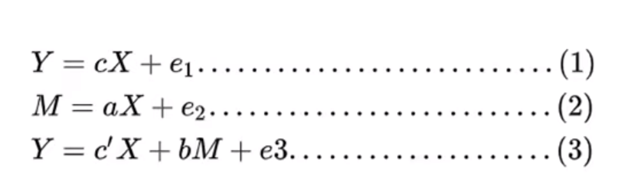

The coefficient **c** should be significant

The coefficient **a** and **b** should be significant

"complete mediation effect" and "partial mediation effect"

**Stepwise Regression:**

----------------------------------------------------

use "http://www.stata-press.com/data/r15/gsem_multmed", clear

reg perform support

reg satis support

reg perform satis support

----------------------------------------------------

**Sobel—goodman mediation test + bootstrap:**

----------------------------------------------------

net install sgmediation2, from ("https://tdmize.github.io/data/sgmediation2")

Download ado file “sgmediation2” and paste into your folder “stata\ado\base”

sgmediation2 perform, iv( support ) mv( satis )

add your control variables into the cv(): sgmediation2 perform, iv( support ) mv( satis ) cv(_id* _year*)

bootstrap r(ind_eff) r(dir_eff), reps(500) : sgmediation2 perform, iv( support ) mv( satis )

----------------------------------------------------

Quiz: try to verify whether there is a mediating effect exists between invest mvalue and kstock

webuse grunfeld,clear